Final Project write up

Question I want to answer:

* From Steam games achievements how can we tell the participation of players on the game they purchased based on that achievement data?
* What players like to do in the game. (Their Behavior in the game.)
  + PS: In the actual data searching, the API data is weird that achieved challenge are not showing unlock requirement. So I decide to use a website source for look up.
* I will also check what games do I own and what are the time I spend on the game furthermore in my other programs you can search game name to get game general information to see that games genre. So you can tell what kind of game genre is my favorite. (I also plotted the bar graph for time data.)
* If you want to purchase a game, you can also use search in my python program to see the recent reviews and overall reviews and, you can also see what is the discounted price compare the original price to make a decision whether or not to by the game.
* I also want to find out what are the top 10 most game developed by developer names in Steam App. How many games and DLCs they developed.
* And I’m also want to know what are the games and DLCs Ubisoft Montreal studio has developed and what are they.
  + PS: in program you can change the parameter 'Ubisoft Montreal' to another name you will get a different result for a different developer.
* I also want to see what are the most appeared primary genre are in the Steam App.
* What are the series of games that my favorite publisher Ubisoft has published in Steam App and prices, as well as their genres.
* I also want to just allow user to input a game name, and the program will return a min and max hardware requirement for that game.
* Last but not least I want to see what are the top 10 most owned games in Steam

How I answer the questions:

For the general question related to achievement in Steam. I used the Valve Developer Community website to find the end point of the challenge information by insert my steam ID and access token. I got what I unlocked. So I did a little bit more search I found the global percentage data that shows the percentage of how many people unlocked certain challenge. From their I just using API and python to get what I want. I have also played the game I tested in the final project, the “Assassin’s Creed Odyssey” I know what are the requirement for certain challenges.( <https://steamcommunity.com/stats/812140/achievements>) this link will took you to the challenge requirement. Also from this challenge requirement you an see most players don’t like explore the map when the map is super huge. For example the challenge “Hermes's Homie” require me to Unveil all sub-regions of Greece which for me personally I didn’t unlock that challenge, because some regions in the map there are no main mission located in those places so I didn’t bother to do that. So, now you can see what people don’t like to do when the map is so big, from my perspective people today like to play “popcorn game” which the story went in a fast pace and interesting, players are not bothered to spend time to explore the map.

For other questions like genres prices and look up game publishers etc. I found two csv files on the internet and I found one file which is created 6 month ago and another created 3 years ago I remember. I just used pandas in Python library to get the data I want. I also used input method to allow user to input a parameter to get the information related to that parameter which I think it could be a good feature when it comes to app design so I just want to practice on that.

I also looked my favorite game publisher see what games they published and what genre are their favorite. Which is my pure interest I just want to see that information, but when it comes to business, you will see oh this company produces this kind of game the most then this might be a common genre for the market … you can dig into this data and find so much more information, but it requires to do a bit more brain storm.

What are the results:

The challenge Odyssey's End marks the game's main story's end. Originally, I expect more than 50% of players will finish this challenge. However, from the data I got from Valve Developer community, only 35.80% of player who purchased this game has finished the main story. Also "The Cult Unmasked" challenge is also a challenge that indicates the end of the main story only 26.9% of people who purchased this game have finished it. There are 35,381 steam owners who own this game which means 35.80% of 35,381 people who finished the challenge and do the math we find out only 12,666 people finished the challenge. This may show that the players are not really appreciate the game as I expected. And may be in the future if the publisher want to produce another game they will research on this data and find out why people drop out of this game in the half way, so when they are producing the next game they could fix the problem and make a better game.

Also like I for mentioned, the challenge “Hermes's Homie” require me to Unveil all sub-regions of Greece which for me personally I didn’t unlock that challenge, because some regions in the map there are no main mission located in those places so I didn’t bother to do that. So, now you can see what people don’t like to do when the map is so big, from my perspective people today like to play “popcorn game” which the story went in a fast pace and interesting, players are not bothered to spend time to explore the map.

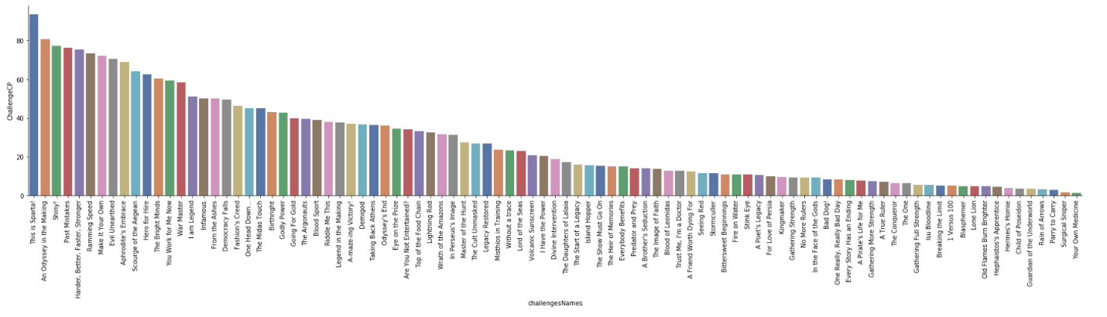

I also found out that I spend more than 700 hours playing Rainbow Six Siege which is and FPS tactical game. This is not surprising because I know I just play that game on steam for the most of the time.

There is also one interesting point that I found is that Ubisoft - San Francisco studio produces most game and DLCs. When I was doing this part I expected it would be some companies like SEGA or Activision etc. So I did try to look up why they are having so many apps produced. I found out that they produced a game called Rocksmith which is a music game, and there are many dlcs are musics from real world that user can buy to play them in game. (<https://store.steampowered.com/search/?developer=Ubisoft%20-%20San%20Francisco>) This link will allow you to see that information. So you can see if you produce a game that will need to use the real world music track you will do a lot work on making dlcs.

If I continue do this work:

I will try to do analysis on the challenge information, because the challenge system is a good way to see what players like to do, as well as how many people are sticking with the game. So I would look into that information see if I can find and formulate more interesting findings. It’s kind like a user behavior research.